US–MENA PRIVATE SECTOR DIALOGUE (PSD) 2026

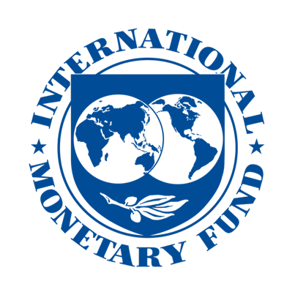
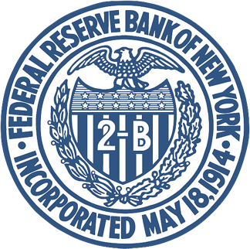
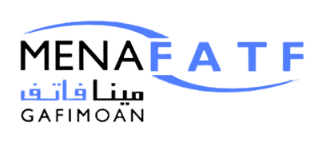
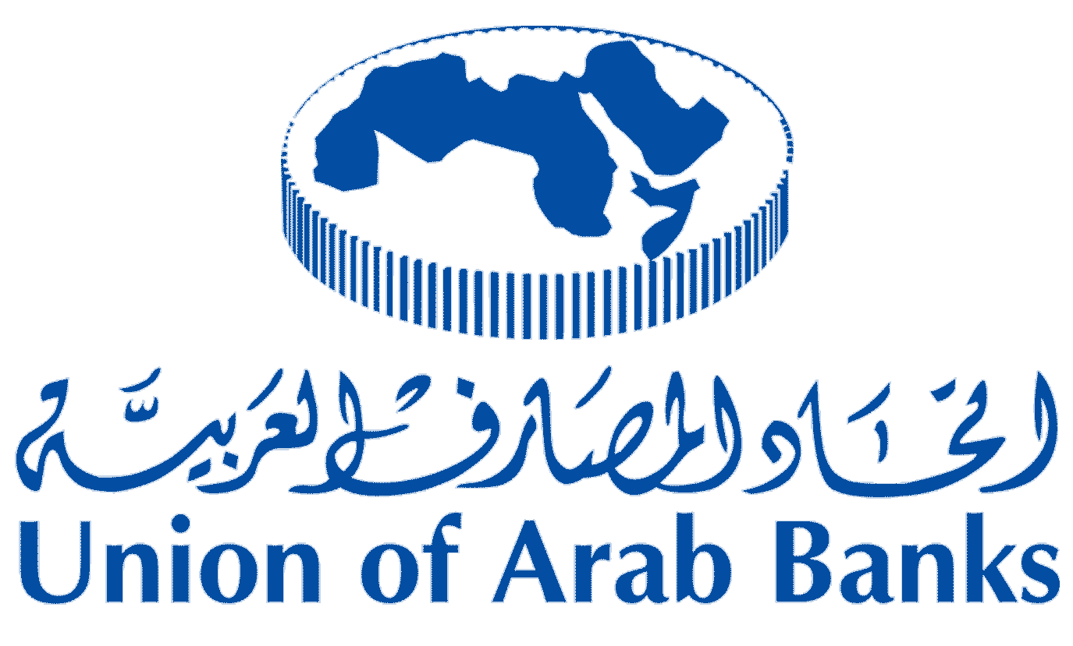

------------------------------------------------------------------------------------------------------------------
With the Participation of the U.S. Department of Treasury
------------------------------------------------------------------------------------------------------------------

Celebrating 20th Anniversary
US–MENA PRIVATE SECTOR DIALOGUE (PSD) 2026

Where U.S. regulatory expectations meet MENA banking leadership.
A high-trust, senior-level banking dialogue focused on correspondent banking access, AML/CFT, sanctions, financial crime, digital assets, AI-enabled compliance, and cross-border payment integrity.

30th October 2026 JP Morgan HQ, New York, USA

Opening and Closing Brochure Statement – Rinoth – mention this on the first page and last page.
US–MENA PSD 2026 is a high-level, invitation-led dialogue focused on protecting correspondent banking access, strengthening regulatory trust and helping MENA financial institutions navigate the next era of AML/CFT, sanctions, digital finance and cross-border compliance.

US–MENA PSD 2026 Partnership Packages

Option 1: Strategic Thought Leadership Partner
Panel Discussion + 10-Minute Presentation Slot
Investment: USD 49,999 Only
The highest-level visibility package, designed for organisations seeking both strategic speaking authority and direct positioning in front of the conference’s senior decision-maker audience.
Package includes:
- 10-minute standalone presentation slot
- One approved panellist seat in a panel discussion of up to 90 minutes
- Upto 4 delegate passes
- Visa support letter (Conditional)
- Expedited visa appointment support (Conditional T&C’s apply)
- Logo placement on selected event collaterals
- Dedicated social media marketing visibility
- Introductions to key stakeholders
- Exclusive Event Magazine Feature

Option 2: Panel Discussion Partner
Investment: USD 34,999 Only
A high-impact thought leadership package for organisations seeking direct participation in the conference dialogue and visibility among senior banking, regulatory and compliance decision-makers.
Package includes:
- One approved panellist seat in a panel discussion of up to 90 minutes
- Upto 2 delegate passes
- Visa support letter (Conditional)
- Expedited visa appointment support (Conditional T&C’s apply)
- Logo placement on selected event collaterals
- Dedicated social media marketing visibility

Option 3: Networking Partner
Investment: USD 19,999 Only
Designed for organisations seeking premium access, visibility and relationship-building within an exclusive US–MENA banking and regulatory environment.
Package includes:
- Upto 2 delegate passes
- Visa support letter (Conditional)
- Expedited visa appointment support (Conditional T&C’s apply)
- Logo placement on selected event collaterals
- Dedicated social media marketing visibility

Important Note
All panellist and presentation slots are subject to review and approval by the conference committee. Logo visibility and collateral placement are subject to applicable terms and conditions.

